***Food Safety: Bringing food from home***

Bringing food from home helps you/your child heal. There are some important things you need to know before doing this:

Please know that the Hospital and Food and Nutrition Services is not responsible for foodborne illnesses as a result from contaminated foods brought in by me or my family members from outside the hospital and Food and Nutrition services the department.

# Use these guidelines when bringing in food for a patient:

1. A patient on regular diet does not need a doctor’s order for food from home.
2. A patient on modified diet must have a doctor’s approval and a written order.
3. Food must match the patient’s prescribed diet. When needed, a dietitian will help with education to stay on the diet.
4. Food must be made in a clean and safe way. Please see the “How to prepare the food” section below.
5. Bring food in a sealed container or sealed bag to prevent cross contamination. Bring in perishable foods in a cooler (or insulated bag) with ice pack to keep them safe at proper food temperatures.
6. Do not use foods that have been out of the refrigerator or cooler for more than two (2) hours. They should be thrown away. Foods that will be eaten at different times should be portioned out and served in a separate container. Foods that will be used at a later time should not enter patient’s room; they should be dropped off at the nursing station.
7. Once food is taken into your child’s room, all food not eaten must be discarded. Please offer only the amount of food you think your child will eat at any one time.
8. Foods stored in refrigerator and dry storage cabinet must be labeled with patient’s name, room number, and an expiration date written on the label. Foods expiration dates are as follows:
   * Prepared foods → 72 hours after food was made.
   * Ready-to-eat foods→ product expiration date.
9. Foods not requiring refrigeration will be stored in a clean, dry cabinet.
10. Food from home can only be kept at CHLA for 72 hours, after that it will be thrown away by nursing staff.

# How to prepare the food:

* Safe preparation of your child’s food is always important. It is even more important when your child’s body is weakened by illness or injury.
* Always prepare food on a clean surface, with clean hands and utensils.
* Be sure food is well cooked.
* Do not bring food with uncooked eggs/meat products in it.
* For safety reasons, the food cannot be stored anywhere else.

Please look at this food safety tip sheet to learn more on safe food preparation. Add Food Safety Tip- English or on Spanish content add Food Safety Spanish.

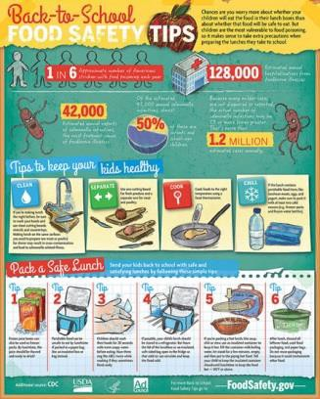 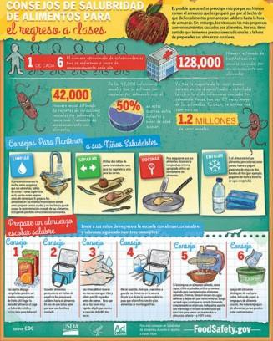

Source: <http://www.foodsafety.gov/keep/events/backtoschool/>

# Remember the Hospital and Food and Nutrition Services is not responsible for foodborne illnesses as a result from contaminated foods brought in by you or your family members from outside the hospital and Food and Nutrition services the department. Thank you for following the guidelines.